1. What status code is returned for a successful DELETE to the server?

204(No Content)

1. Using Postman, do screen print showing a successful DELETE of your choice.

I deleted everything on accident.

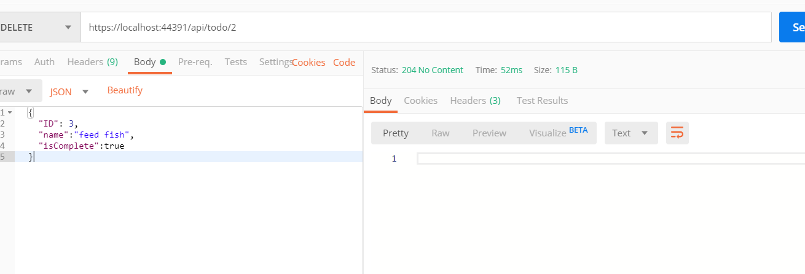

1. Using Postman, do a screen print showing a GET for the item deleted from the previous exercise.

There is one field because it auto-generates one

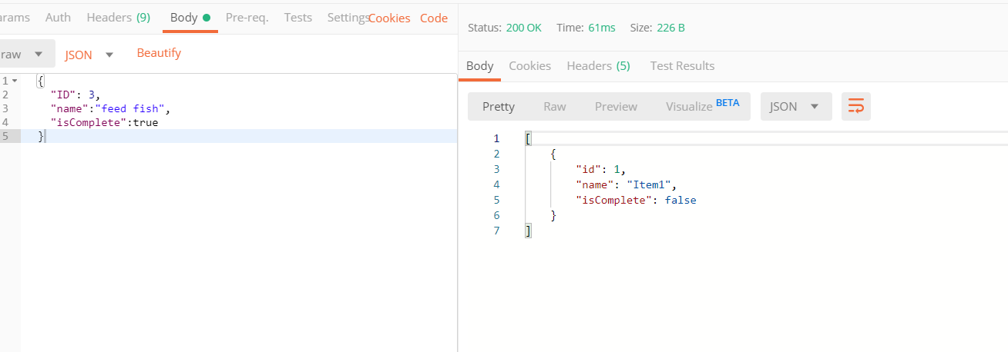

1. What status code is returned from the previous exercise?

404 not found